SIMATS ENGINEERING
NAME: A.Preetika Sudhakar
RREG NO. 192371073
COURSE NAME: Database Management Systems
COURSE CODE: CSA0501

Ex. No.: 9
Query with Joins – EquiJoin, InnerJoin, OuterJoin
AIM: To perform JOIN using Equi Join, Inner Join, Outer Join on the given relation.
DESCRIPTION:
JOIN
A MySQL join is a method of linking data from one or more table based on values of the common column between tables.
MySQL supports the following types of joins:
1. Cross join
2. Inner join
3. Left join
4. Right join
CROSS JOIN
The CROSS JOIN makes a Cartesian product of rows from multiple tables. Suppose, you join t1 and t2 tables using the CROSS JOIN, the result set will include the combinations of rows from the t1 table with the rows in the t2 table.
CROSS JOIN:
SELECTt1.id, t2.id
FROMt1CROSS JOIN t2;
INNER JOIN:
SELECTt1.id, t2.id
FROMt1INNER JOINt2 ON t1.pattern = t2.pattern;
LEFT JOIN:
SELECTt1.id, t2.id
FROMt1LEFT JOINt2 ON t1.pattern = t2.pattern
ORDER BY t1.id;
RIGHT JOIN:
SELECTt1.id, t2.id
FROMt1RIGHT JOINt2 ON t1.pattern = t2.pattern
ORDER BYt2.id;

Questions:
1. List the departments where the faculty members are working.
2. Find the student who has no score in any of the courses. List student name and course number. 3. The office clerk needs the names of the courses taken by the faculty belonging to ‘ECE department’ whose name is ‘Kamal’

OUTPUTS:
1. List owners and the plots they own (INNER JOIN)
SELECT o.owner_id, o.city, p.plot_no, p.location FROM owners o INNER JOIN plots p ON o.owner_id = p.owner_id;

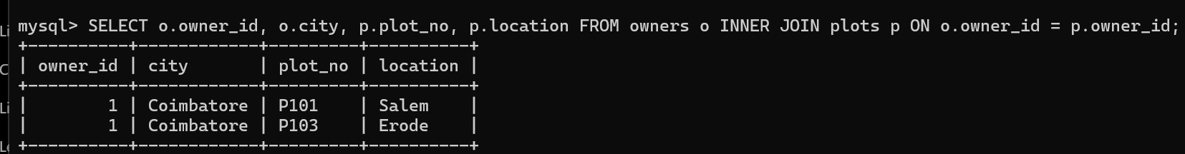

2. Find owners who have no plot (LEFT JOIN)
SELECT o.owner_id, o.city FROM owners o LEFT JOIN plots p ON o.owner_id = p.owner_id WHERE p.plot_id IS NULL;
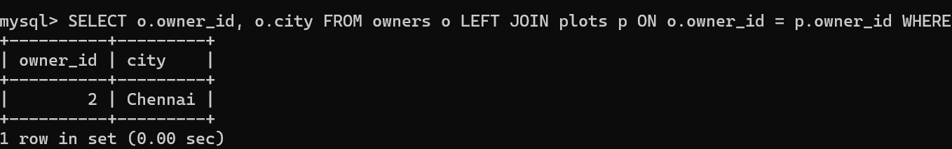

3. Display plot details with payment amount (INNER JOIN)
SELECT p.plot_no, p.location, pay.amount FROM plots p INNER JOIN payments pay ON p.plot_id = pay.plot_id;
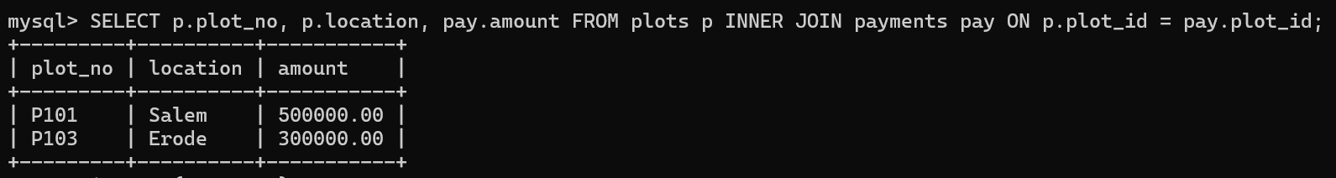

RESULT: The records from the tables are displayed using JOIN using EquiJoin, InnerJoin, OuterJoin.

